**Mountains:**

Mount Godwin-Austen/K2

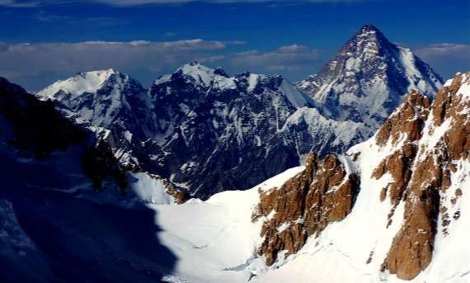

**K2** ( **Kai Ṭū**), also known as **Mount Godwin-Austen** or **Chhogori** at 8,611 metres (28,251ft) above sea level, is the second highest mountain in the world, after Mount Everest at 8,848 metres (29,029ft). It is located on the China–Pakistan border between Baltistan in the Gilgit-Baltistan region of northern Pakistan, and the Taxkorgan Tajik Autonomous County of Xinjiang, China. K2 is the highest point of the Karakoram range and the highest point in both Pakistan and Xinjiang. K2 is known as the *Savage Mountain* due to the extreme difficulty of ascent. It has the second-highest fatality rate among the eight-thousanders, with around 300 successful summits and 77 fatalities; about one person dies on the mountain for every four who reach the summit. It is more difficult and hazardous to reach the peak of K2 from the Chinese side, so it is usually climbed from the Pakistani side.  K2 has never been climbed during winter, unlike Annapurna, the mountain with the highest fatality-to-summit rate (191 summits and 61 fatalities), or the other eight-thousanders. Ascents have almost always been made in July and August, the warmest times of year; K2's more northern location makes it more susceptible to inclement and colder weather.

Nanga Parbat

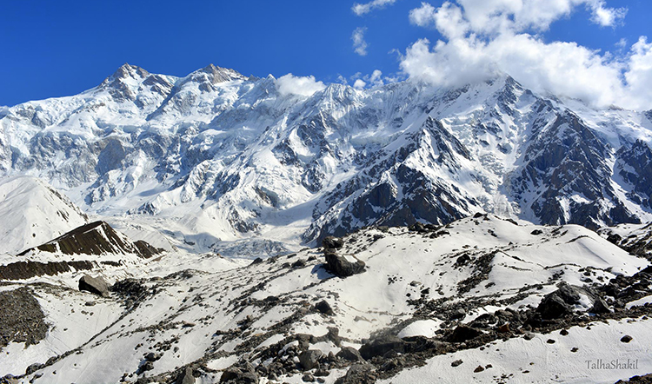

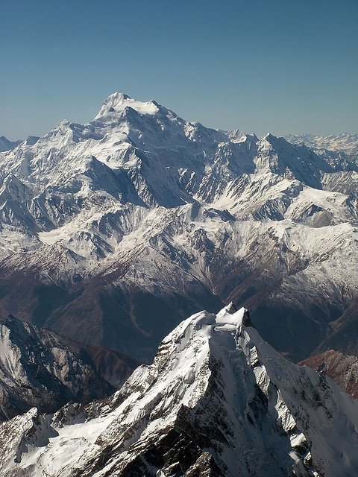

**Nanga Parbat** locally known as **Diamer** , is the ninth highest mountain in the world at 8,126 metres (26,660ft) above sea level. Located in the Diamer District of Pakistan’s Gilgit Baltistan region, Nanga Parbat is the western anchor of the Himalayas. The name Nanga Parbat is derived from the Sanskrit words **nagna** and **parvata** which together mean "Naked Mountain". The mountain is locally known by its Tibetan name **Diamer**or **Deo Mir**, meaning "huge Mountain".Nanga Parbat is one of the eight-thousanders. An immense, dramatic peak rising far above its surrounding terrain, Nanga Parbat is also a notoriously difficult climb. Numerous mountaineering deaths in the mid and early-20th century lent it the nickname "Killer Mountain.”

Tirich Mir

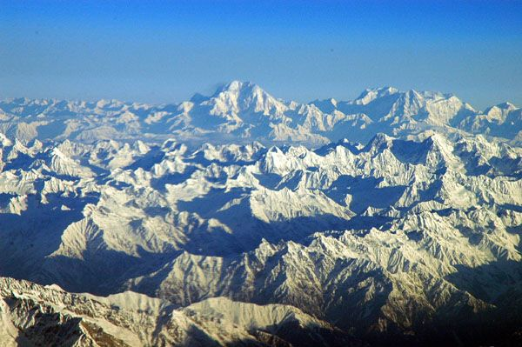

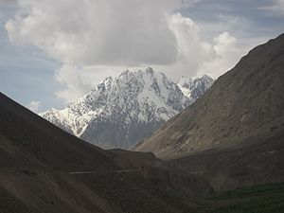

**Tirich Mir** (alternatively **Terich Mir**, **Terichmir** and **Turch Mir**) is the highest mountain of the Hindu Kush range, and the highest mountain in the world outside of the Himalayas Karakoram range, located in Chitral District of Pakistan. The mountain was first climbed on 21 July 1950 by a Norwegian expedition consisting of Arne Næss, P. Kvernberg, H. Berg, and Tony Streather. Tirich Mir overlooks Chitral town, and can be easily seen from the main bazaar.

Kirthar Mountains

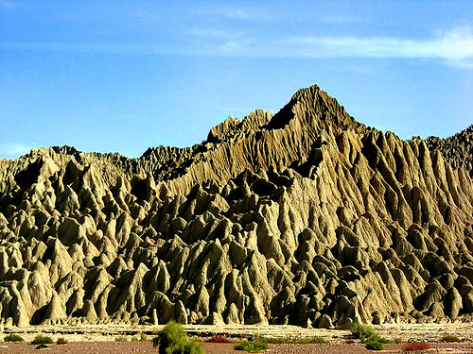

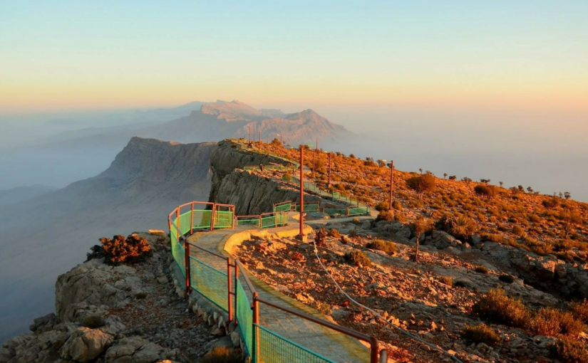

The **Kirthar Mountains** are a mountain range located in the Pakistani provinces of Balochistan and Sindh. The mountains extend southward for about 190mi (310km) from the Mula River in east-central Balochistan to Cape Monze on the Arabian Sea. The Kirthar Mountains form the boundary between the lower Indus Plain (to the east) and southern Balochistan (to the west). It consists of a series of parallel rock hill ridges rising from 4,000ft (1,200m) in the south to nearly 8,000ft (2,400m) in the north.

Koh-e-Chiltan

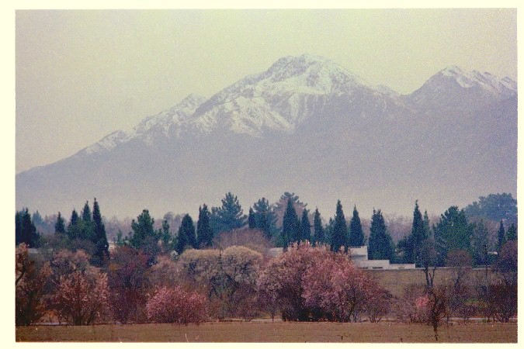

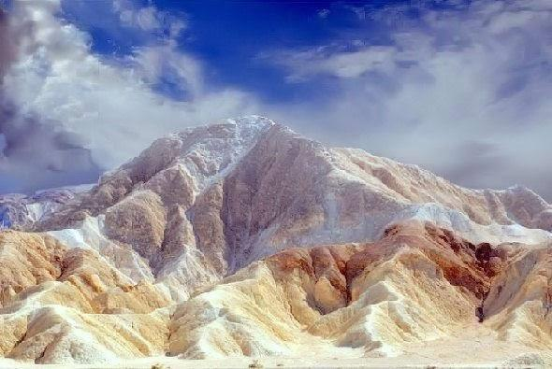

Koh-i-Chiltan is the summit of a steep, rocky mountain called Chiltan or Chehel-Tan (Persian/Balochi: 'Forty Bodies'). 'Lwarrh Saar' is the highest peak of Chiltan mountains range at 3,194 metres (10,479ft), it is the third-highest peak of Quetta after Zarghoon Ghar and Koh-i-Takatu, and fifth-highest peak of Balochistan. There are many juniper trees found in high ranges.

Rakaposhi

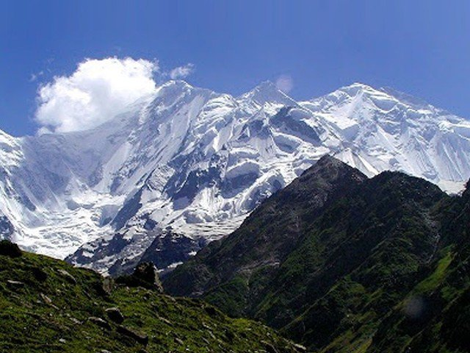

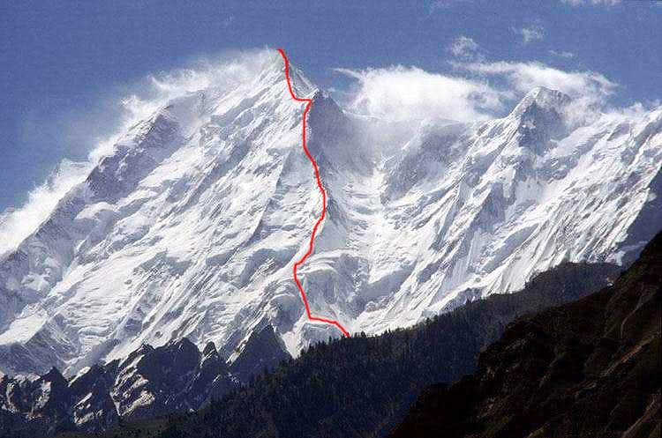

**Rakaposhi** is a mountain in the Karakoram mountain range in the Gilgit-Baltistan region of Pakistan It is situated in the middle of Nagar Valley Nagar District and Danyore and Bagrote valley approximately 100km (62mi) north of the capital city Gilgit of the semi autonomous Gilgit-Baltistan region of Pakistan. Rakaposhi means "Snow Covered" in the local language. Rakaposhi is also known as Dumani ("Mother of Mist" or "Mother of Clouds"). It is ranked 27th highest in the world.